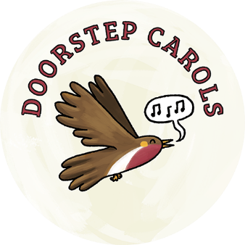
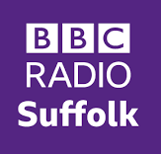
Doorstep Carols Suffolk
14th December 2022
6-7pm
http://www.lightwave.community/doorstep-carols

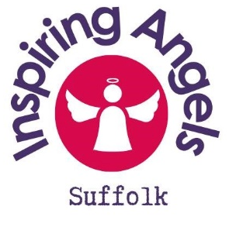
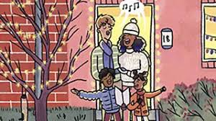
HOW CAN YOUR CHURCH OR
SMALL GROUP
FLOURISH IN ITS WITNESS
THROUGH DOORSTEP CAROLS?

Why Doorstep Carols?

Everyone loves Christmas Carols and an opportunity for a good sing. When Doorstep Carols started in 2020, opportunities for singing were very limited and Doorstep Carols was a Covid-safe way of combatting loneliness and sharing some Christmas cheer, taken up by thousands of people, including many who wouldn’t usually go to a carol service. Radio Suffolk played the carols and hundreds of streets and villages joined in, many led by local Christians. The following year Doorstep Carols remained popular and now Doorstep Carols can meet in larger outdoor spaces as well as doorsteps. It is not just churches getting involved – but for local churches, it is an especially wonderful opportunity to share God’s love and to cherish relationships in our whole community. You can serve hot chocolate and angel biscuits or a halo and make it into an Inspiring Angels Event.

What opportunities does Doorstep Carols bring for a local church, chapel or group?

Singing carols and getting to know our neighbours is good in itself. Even better if we can raise some funds for a good cause or speak on the radio about what we are doing. On top of this, Doorstep Carols creates opportunities for people who may be seeking, to find out about Christian faith. One of the things that we all find hard is talking to our neighbours directly about faith. Sometimes it’s easier to talk about almost anything else! Singing Christmas carols can open up conversations – people may talk about their experience of singing Carols at Christmas in the past and maybe how and why they love them. For some that could lead to an opportunity to see where people are on their Christian journey. Or you may discover loneliness or practical needs in your community in which you can partner with others for the good of all.

Doorstep Carols really helps because it’s Suffolk-wide (actually nationwide!), something lots of people will love to do. We have made some attractive, accessible invitations and carol sheets which you can customise to get people thinking and/or direct them to other events in the local community they can get involved with.

Some Examples

A neighbour talks about feeling isolated and finding the year really hard. They enjoy the singing and come along to some Christmas services advertised on the carol sheet with the neighbour who invited them. It is the beginning of new friendships, walks together and joining in with the church community café in the new year.

A young mum expresses a desire to find something to help my their small child to engage with faith, or with Christmas, or simply with singing. That might spark an idea for something you could invite her and her child to in the future. That could be a toddler group, or simply meeting up for a walk?
Things which could come out of Doorstep Carols as follow-up events might be:
- A toddler group, even a toddler singing group and have the conversations…
- A coffee morning. Something for the street - Plan something for Easter?
- Some kind of community singing?
- A walking group, or opportunity for walks in pairs
- An alpha course
Thinking and praying about your witness

- Recognise that everyone is individually on a faith journey and making contact with folk through an opportunity like this is an opportunity to understand a bit more where individuals are on that journey and might give you an opportunity to help them progress on that path and find something which could be easily accessible to them to which you could invite them in the future.
- When you plan something, find someone else you can plan/partner with, who is already not a Christian
- Has your conversation/contact started to identify any common interests with people? What common interests do you have with people in your road/area?
- Pray in the days leading to this event for opportunities, praying with open eyes, looking for person of peace – the person God might be leading you to open the door to entering their world.
- Remember that God is already at work in the people you are singing with and he wants us to discern where he is at work, and join in with it.
- If someone in your road has a real concern for others and their mental wellbeing then that is God working in them. Ask yourself, how is God calling you to come alongside them and encourage them. In encouraging them to develop their gifts we are encouraging them to discipleship
- Think about being a blessing where God has placed you, and giving opportunity to see Jesus in their lives – he’s already there working!

So…

Doorstep Carols and other similar events give us an opportunity to
- Build and cherish relationships
- See where people are on their spiritual journey
- Start conversations and see how we can come alongside to support

To get involved with Doorstep Carols Suffolk…

- Pray about the opportunity and go to www.lightwave.community/doorstep-carols for further information and downloadable invitation/carol sheets
- Customise the carol sheet and see which members of your group could deliver them to their road and invite their neighbours to sing with them. Ask neighbours to help where you can.
- Pray for the roads as people are invited and prepare your hot drinks or other plans
- Expect God to give you opportunities to get to know people better, to serve and bless them and to share faith.
- Share in your group what you learned about this and build on ways you discover to bless your neighbourhood

Lightwave Contacts who can help and advise with your local witness

The Lightwave Community is a Suffolk-wide community which is all about shining God’s Light in Suffolk through small groups of small groups. We are delighted to be partnering with Radio Suffolk to facilitate the Doorstep Carols initiative.

You can contact Lightwave leaders at any time of year to help and advise with your local witness:
Small Groups shining God’s Light in Suffolk
- Rev Diane Grano – leader of the Red Lodge Area Lightwave Rural Hub: diane.grano@cofesuffolk.org 07403 210793
- Ben Wale – leaders of the S East Area Lightwave Rural Hub: ben.wale@cofesuffolk.org
- Rev Edward Land – Outreach Minister with the Lightwave Rural Hub for “Bungay and Beyond”: edward@htbungay.org
- Nina Seaman – Administrative help and Prayer Coordinator – 07394 559889
- Andrew Gosden – Interim Doorstep Carols Co-ordinator - 07711 753312 and andrew.gosden@cofesuffolk.org

http://www.lightwave.community/doorstep-carols
You can also see what others are doing and share your experiences by joining the facebook group
Doorstep Carols Suffolk https://www.facebook.com/groups/756790964906018/?ref=share

